|  |  |  |  |  |  |
| --- | --- | --- | --- | --- | --- |
|  |  | | |  | |
|  |  | **AMERICAN INTERNATIONAL UNIVERSITY – BANGLADESH**  **Faculty of Engineering** | | | |
| **Course/Lab Name**: | | | Data Communication | | |
| **Semester: Spring** 2023-24 | | | | **Term**: Final | **Assignment-2** |

**Question Mapping with Course Outcomes:**

|  |  |  |  |  |  |  |  |
| --- | --- | --- | --- | --- | --- | --- | --- |
| **Item** | **COs** | **POIs** | **K** | **P** | **A** | **Marks** | **Obtained Marks** |
| **All Problems** | **CO4** | **P.f.2.C6** | **K7** | **.** | **.** | **30** |  |
| **Total:** | | | | | | **30** |  |

**Student Information:**

|  |  |  |  |
| --- | --- | --- | --- |
| **Student Name: MD MEHEDI HASAN POLAS** |  | **Student ID:22-46566-1** |  |
| **Section: H** |  | **Department: CSE** |  |

**Instructions for submission:**

1. Use this page as a cover page.

2. Take pictures of your written answer and paste under each problem given below.

3. Give the file name using the middle 5 digits of your student ID.

For instance: if your ID is 20-40708-3 your file name will be 40708.pdf

4. Upload the pdf file to MS Teams under the assignment section. **Not through direct message to me.**

5. The submission will not be considered if the instructions are not followed.

**Answer the following Questions:**

**Problem 01**: For the available bandwidth of 200 kHz, which spans from 200 to 400 kHz. **Compute** followings:

1. the carrier frequency for half duplex mode,
2. the bit rate, if modulation is done by using ASK in half-duplex mode with d = 1?. **Sketch** the frequency spectrum for ASK in half-duplex.
3. the bit rate, if modulation is done by using BFSK with d = 1. **Sketch** the frequency spectrum for BFSK.

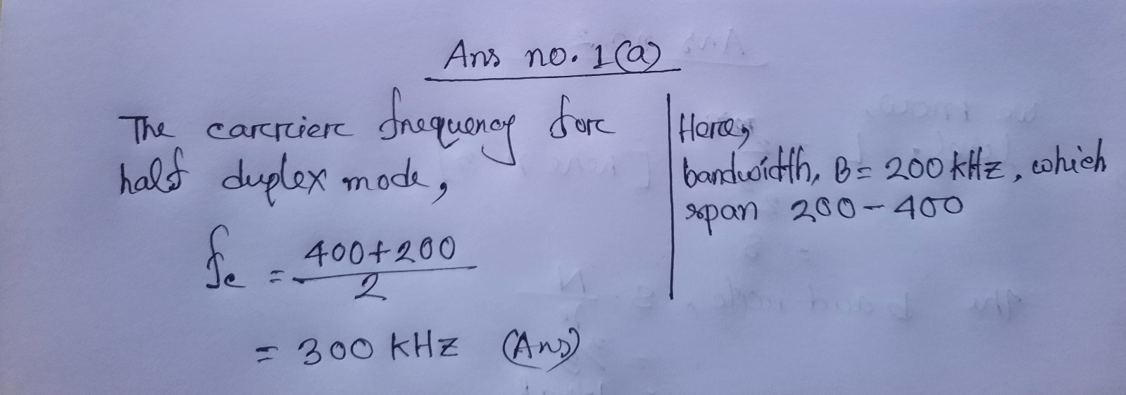**Answer**:

**Problem 02***:* We need to send 3 bits of data at a time at a bit rate of 3 Mbps. The carrier frequency is 12 MHz. **Compute** the number of levels (different carrier frequencies), the baud rate, and the bandwidth. **Illustrate** the frequency spectrum showing the bandgap between the required carrier frequencies.

**Answer:**

**Problem 03**: **Compute** the bandwidth for a signal transmitting at 14 Mbps for QPSK considering the value of d = 1.

**Answer:**

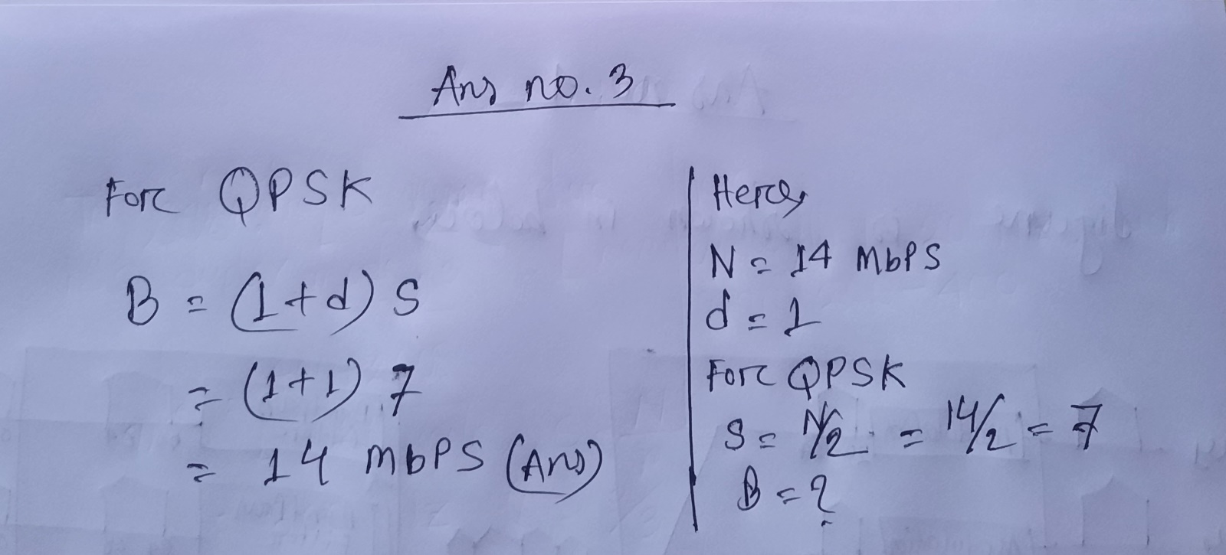

**Problem 04**: Assume a voice channel occupies a bandwidth of 4 kHz. We need to combine four voice channels into a link with a bandwidth of 20 kHz, from 20 to 40 kHz. **Illustrate** the configuration, using the frequency domain. Assume there are no guard bands.

**Answer:**

**Problem 05**: Six channels, each with a 200-kHz bandwidth, are to be multiplexed together using frequency division multiplexing (FDM). **Compute** the minimum bandwidth of the link if there is a need for a guard band of 10 kHz between the channels to prevent interference? **Sketch** the spectrum diagram for the whole bandwidth span of these six channels with five guard bands.

**Answer:**

**Problem 06**: Four digital data channels, each transmitting at 1.5 Mbps, use an analog satellite channel with a bandwidth of 1 MHz. **Compute** the appropriate modulation scheme and its order to covert the digital channel data fit for analog satellite channel. **Design** an appropriate configuration to multiplex these four data channels data by using chosen modulation scheme and FDM.

**Answer:**

**Problem 07**: Five 1 kbps connections are multiplex by using synchronous TDM. A unit is 1 bit for each timeslot within each frame. **Compute** followings: (**i**) duration of 1 bit before multiplexing, (**ii**) output transmission rate, (**iii**) duration of a timeslot within a frame, (**iv**) frame rate, and (**v**) frame duration.

**Answer:**

**Problem 08**: Three sources each creating 100 characters/second and each character size is 1 byte. If the interleaved unit is a character and one synchronizing bit is added to each frame, **compute** followings: (**i**) data rate for each source, (**ii**) frame size, (**iii**) frame rate, (**iv**) frame duration, (**v**) data rate of the link.

**Answer:**

**Problem 09**: A synchronous time division multiplexer combines five 100 kbps using a time slot of 2 bits. **Compute** followings: (***i***) frame rate, (***ii***) frame duration, (***iii***) frame size, (***iv***) bit rate, and (***v***) bit duration.

**Answer:**

**Problem 10**: Four input channels, two with a data rate of 5 kbps, one with 10 kbps each, and the last one with data rate 7 Kbps, need to be multiplexed using synchronous TDM. A maximum of 3 Kbps data can be added using the pulse stuffing method. **Illustrate** the data rate mismatch problem solution by showing suitable data rate management techniques.

**Answer**:

**The End**